**Brooklyn torah gazette**

**For parshas Pinchas 5779**

Volume 3, Issue 46 (Whole Number 143) 24 Tammuz 5779/ July 27, 2019

**Printed L’illuy nishmas Nechama bas R’ Noach, a”h**

For a free subscription, please forward your request to [***keren18@juno.com***](mailto:keren18@juno.com)

**Rabbi Dovid Goldwasser on**

**The Benefits of Reciting**

**Chapters of Tehillim**

**By Daniel Keren**

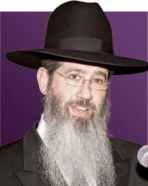

Summer in Flatbush officially began with the July 4th Independence Day legal holiday Hakhel Yarchei Kallah that was held at the Agudath Israel of Madison. The Independence Day Hakhel Event began with an insightful lecture by Rabbi Dovid Goldwasser, internationally renowned Maggid Shiur and Rav of Congregation Bais Yitzchok on the topic of “The Phenomenon of Tehillim- A Deeper Look.”

“Sefer Tehillim [the Book of Psalms] is a wonderful matanah (gift) that Hakodesh Baruch Hu has given us,” Rabbi Goldwasser said. Yaakov Avinu according to a navuah (prophecy as mentioned in the Midrash Bereishis Rabbah 68:12) read the entire Sefer Tehillim [that would later be written down by Dovid Hamelech, King David bi’maisah and that unique reading by our Patriarch has bestowed upon all of his descendants in future generations that valuable ability to gain chizuk and encouragement to withstand all of our difficulties to the end of times.

Where is Tehillim from? We learn from Bava Basra (15a) that other than Dovid Hamelech who wrote most of the Book of Psalms, other chapters in Sefer Tehillim were composed by Adom Harishon (Adam), Melchizedek and Avraham.

(Bava Basra 14b) ) also credits as composers of select psalms in Sefer Tehillim to Moshe, Heiman, Yedutun, Asaph and the three sons of Korach.

Rabbi Goldwasser explained that when a Jew is osek (active in reciting) Tehillim, they are not only davening (praying) but are simultaneously engaged in the study of Torah.

The Brisker Rav [Rabbi Yitzchok Zev Halevi Soloveitchik, 1886-1959) after the Mussaf service on Rosh Hashanah was seen by his talmidim instead of taking a Mesechta (tractate) of Gemorah [the traditional format of studying Torah] to take a Sefer Tehillim and spend the free time to recite kapitlach (chapters) of Psalms.

Rabbi Goldwasser addressed the question that is particularly appropriate in the summer when many people don’t dress with tznious (modestly). Can a person recite or continue to recite Tehillim on a subway or bus if someone enters the bus and sits and stands nearby who is not dressed modestly?

The Vilna Gaon poskened (ruled) that one cannot recite Tehillim or study Torah in such a situation. Other poskim do permit the recitation of Tehillim if one is able to look downwards and thereby avoid seeing the immodestly dressed individual.

It is praiseworthy to read Tehillim during the daytime. Many sources, Rabbi Goldwasser said that one should not read chapter of Tehillim at night, except in times of great sakanah (danger.)

Reciting Tehillim is a great collection of 150 segullahs (spiritual cures) that should be taken advantage of whenever one is confronted by distress. A very good kapital (chapter) of Tehillim is Lamnatzeach (Chapter 20) that should be taken advantage whenever one is confronted by distress. Lamnatzeach should be said in times of tribulation, especially in childbirth. The segulah of Tehillim can be broken down to particular chapters to help in various difficulties.

Whenever a person needs to be saved, one should direct his or her hopes to that Source which can assist and not place their trust in a basar v’dam (human being.)

Rabbi Dovid Goldwasser was once asked for a segulah for someone who had to take an important academic test. He answered that Rabbi Meir Shapiro, the originator of the Daf Yomi concept said that a potent segulah for the school test is to recite the long Chapter 119. However, there is one caveat – you must still do the hishtadlus of studying the material for that test.

Family members of a woman undergoing difficulty in giving birth should recite all nine different chapters (11, 12, 13, 14, 18, 19, 20, 21 and 22) of Tehillim that begin with the word Lamnatzeach into the ear of the woman giving birth. Those nine kapitlach of Tehillim correspond to the nine months of pregnancy.

The Zohar Hakodesh says that there are 70 words in Lamnatzeach (Chapter 20) and that this corresponds to the 70 cries of a woman in the pangs of childbirth. This kapital ends with the words “Hashem Hoshia, Hamelech Ya’aneinu biyom kar’einu/Hashem save! May the King answer us on the day we call.”

If a person has emunah sheleimah (complete faith) on the highest level, there is no reason why he or she can’t be answered by Hashem immediately.

The person who takes upon himself or herself to recite Tehillim with great sincerity has opened the gates of personal salvations. The segulah of reading Tehillim comes from reading them in lashon hakodesh (Hebrew). But there is nothing, Rabbi Goldwasser explained that is wrong with after reading the chapters of Tehillim (at least five kapitlach a day) in Hebrew, if one doesn’t understand the meaning of the words, to then read those chapters a second time in English. But for the purpose of segulahs (spiritual cures) one must read the Tehillim in lashon hakodesh.

**The Shmuz onParshas Pinchas**

**The Voice Inside**

**By Rabbi Bentzion Shafier**

**Founder of TheShmuz.com**

*“Pinchas, the son of Elazar, the son of Aharon HaKohain, appeased My anger against the Bnai Yisroel by taking My revenge amidst them, and so I didn’t have to destroy them with My vengeance*.” — Bamidbar 25:11

**Pinchas Was Granted a Bris Shalom**

*The posuk* tells us that because Pinchas defended the honor of HASHEM, he was granted a “*bris* of *shalom*.” The *Siforno* explains that as a result of this covenant of peace, Pinchas lived to an extraordinary age – far longer than was expected in his times. However, the *Siforno* points out that the reason for his longevity wasn’t supernatural, but rather because he was granted this *bris.* Since he was given *shalom*, he was at peace with himself, and as a result, he didn’t suffer the normal internal conflict that causes damage to our bodies. He therefore lived to an extremely old age.

The *Siforno* explains, “All deterioration happens to the body because of **conflict of the opposites**.” In other words, all disease, infirmity, and weakening with age only occurs because of internal conflicts. Since Pinchas was granted peace, he had no internal battles; therefore, his body didn’t age, and he lived hundreds of years.

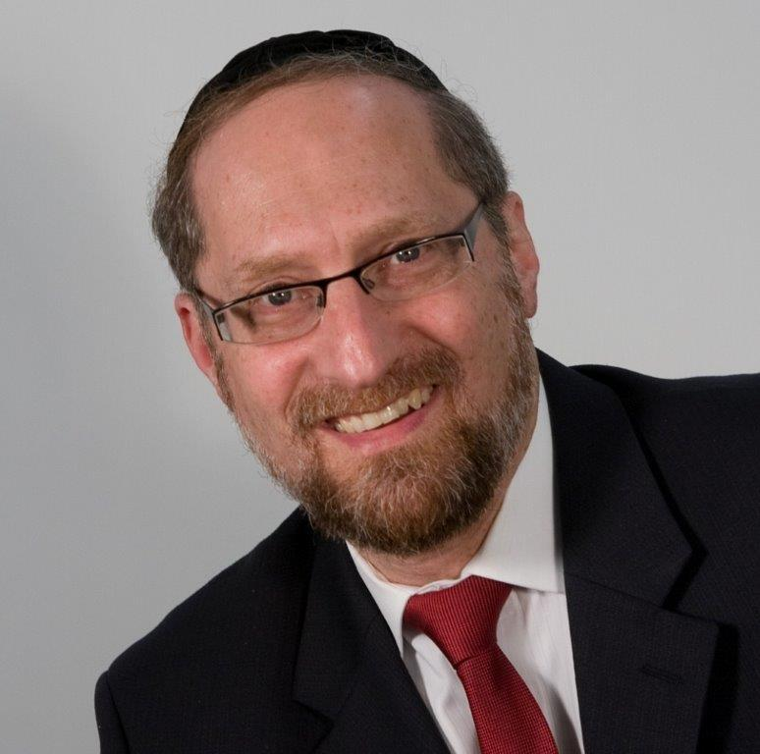

**Rabbi Bentzion Shafier**

The body was made to last only so long…

The difficulty with this understanding of the *Siforno* is that it negates our basic understanding of health. The reality is that humans age. The heart, the liver, and the pancreas were designed to function only for a given length of time. After that, they break down. Infirmities and weakness come naturally with old age. Arthritis, high blood pressure, and the thickening of the arteries are a part of life. While the heart may be a remarkable living pump, the valves start to weaken with time, the muscle tissue begins to break down, and it deteriorates with age. The body was made to last only so long; then it just wears out. So how can the *Sifrno* argue with our accepted understanding by stating “All deterioration happens to the body because of **conflict of the opposites**.”

**Mind/Body Relationship**

The answer to this question is based on 20th century medical findings. Herbert Benson, M.D., Ph.D., was a professor of medicine at Harvard University in the 1960’s when he stumbled upon an unusual phenomenon. He found that when a patient’s blood pressure was taken in his office, invariably it was higher than when it was taken at home. His patients would regularly report blood pressure levels significantly lower than what was found in his office.

After careful study, he concluded that anxiety contributes to high blood pressure. Being examined by a doctor was causing his patients to be nervous, and that was contributing to the rise in their blood pressure.

While it may seem obvious to us today, at the time it wasn’t at all clear that there was a correlation between stress and high blood pressure. For decades, it was assumed that a person’s **mental condition** had no effect on his **physical condition**. Any reported effects of stress and anxiety on health were taken as psychosomatic or imagined.

Benson’s discovery led him to firmly establish the correlation between stress and high blood pressure, and he became a pioneer in a new field of medicine: the relationship between **mind** and **body**. Since those times, it has become accepted in the medical community that stress causes a marked deterioration to a person’s health. Stress can bring about heart disease, gastrointestinal disorders, pain, insomnia, asthma, allergies. . . It is now accepted medical opinion that along with diet and exercise, the lowering of stress levels is a major contributor to a person’s overall health.

This is something that the *Siforno* taught us over 500 years ago. What he was saying was that Pinchas **naturally** lived for hundreds of years because the normal cause of deteriorating health didn’t apply to him. He wasn’t in conflict; he was at peace with himself, and as such, his body was healthier and able to live to a astonishingly advanced age.

**The Ultimate Cause of Distress – the Voice Inside**

This concept has major ramifications in our lives. When HASHEM created man, He implanted into each of us an inner sense of right and wrong, a Voice Inside that allows us to know the correct course of behavior for each situation. More than simply a moral compass, this Voice Inside acts as our guide to self-perfection.

When a person listens to that voice, he lives a fulfilling, meaningful life as his Creator intended, and he is at peace with himself. If he chooses to ignore that voice, not only doesn’t he grow to the heights for which he was destined, he lives in discord and conflict because the voice doesn’t give him any rest.

*“*Why did you do that? That was selfish. I am ashamed of you,” rags on that Voice Inside.

He didn’t ask for or choose that voice. He may no longer want it, but the voice is there, and speak it does – often against his wishes:

“Why are you living your life that way? Why aren’t you learning more? Why aren’t you davening like a *mentsch*? What do you think you were put on this planet for?”

Many times, the person may even want to scream at that voice, “Leave me alone! What are you – my *Rebbe* or something?!” But the voice doesn’t stop. He may ignore it for a while. He may squelch it down, but it returns over and over, giving him no rest. If a person decides not to listen to that voice, one of the prices he pays is discord and inner conflict. He at war with himself, and he suffers.

HASHEM created the human to be healthy, happy, and to live a fulfilling life. If a person lives in accordance with the wishes of his Creator, not only does he grow as a person, he lives a peaceful, happy life. However, if he chooses to ignore that path, not only doesn’t he accomplish the purpose for which he was created, he suffers greatly in this world as well. He lives in discord with his inner sense and finds no peace, joy, or happiness in his existence.

*Reprinted from this week’s website on TheShmuz.com This is an excerpt from the [Shmuz on the Parsha book](https://theshmuz.com/product/shmuz-on-the-parsha-book/).*

**The Physical and Spiritual**

**Inheritance of Every Jew**

**From the Talks of the Lubavitcher Rebbe**

**Rabbi Menachem Mendel Schneerson, Zt”l**

This week's Torah portion, Pinchas, describes the apportionment of the Land of Israel. The Torah states, "Through the lot shall the land be divided." The Talmud notes that the process by which the lots were drawn was neither arbitrary nor random; the miraculous “Urim” and “Tumim”, in the breastplate of the High Priest, guided the outcome.

Rashi explains that not only was the portion of the Holy Land to be given to each tribe written on the lot picked for that tribe, but the lot itself spoke and announced the result. In other words, the division of the soon-to-be conquered Land of Israel was determined by G-d Himself.

The inheritance of the physical portion of land is symbolic of the spiritual inheritance of every Jew with which he is enjoined to fulfill his individual mission in life. Just as each of the Twelve Tribes was given a specific portion of land to live in and cultivate, every Jew is allotted his own spiritual realm to perfect.

Although a person might think he is free to choose his own spiritual portion, following whichever path in the service of G-d that appeals to his nature, the Torah teaches that this is not a matter of free will or logic, but is ordained by G-d.

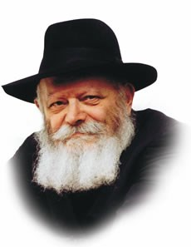

**The Lubavitcher Rebbe, zt”l**

Every Jewish soul has its own particular inclinations and disinclinations; some mitzvot are easier to observe than others. The Talmud notes that many of our Sages were especially careful in their performance of one particular commandment. Although they certainly observed all 613 of the Torah's mitzvot, their performance of that one mitzva was especially praiseworthy. The exemplary observance of that one mitzva served as the conduit through which all other mitzvot flowed.

A person cannot choose his own spiritual bent; it is an integral part of his individual spiritual makeup. But how does one determine exactly which mitzvot are especially relevant to him? By objectively ascertaining those which he finds the hardest to do!

A person may safely assume that a given direction is his "inheritance" whenever the path seems strewn with obstacles and hindrances. In fact, the more important the mitzva, the harder the Evil Inclination tries to dissuade the person.

A lack of interest in a particular facet of Torah study or indifference to a certain mitzva indicates that it is precisely in these areas that special efforts must be made. In the merit of this effort, G-d grants the individual success in all other areas of his life as well.

*Reprinted from the Parashat Pinchas 5753/1993 edition of L’Chaim Weekly (Issue #275), a publication of the Lubavitch Youth Organization in Brooklyn, NY.*

**Rav Avigdor Miller on Proving The Authenticity of the Torah**

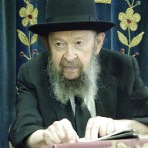

**QUESTION:** Can you prove the authenticity of the Torah?

**ANSWER:** So we say to the questioner, you have the floor, please disprove it. Please disprove the authenticity of our Torah. The Torah is here. Here it is, and here we are. We are the nation that claims that our fathers gave us this Torah that they received from their fathers, and we received a tradition that Moshe our teacher gave it to them, and our entire nation stood at Har Sinai and they heard Hakodosh Boruch Hu speak to Moshe and give him a mandate in their presence. "Moshe Rabbeinu, you're going to speak to this people for Me from now on."

And therefore, Moshe Rabbeinu when he gave us the Torah was mandated by Hakodosh Boruch Hu in the presence of 600,000 males between 20 and 60 years of age - not to mention the elderly ones, the young ones and the women. That's our claim; no nation in the world ever claimed such a thing.

The Mohammedans don't make that claim about the Koran. Of course, the Mohammedans claim that the Bible is true because the Jews say so. Christians also claim the Bible is true, because the Jews say so. But when it comes to their books, they make no such claims. Who else? The Vikings? They didn't have any traditions.The Buddhists don't have any traditions, they made no such claims.

We are the only ones who claim that Hakodosh Boruch Hu gave it to us. And if you'll ask, how do we know that it's true? So we'll ask you a question: How do you know that there was a George Washington? ProveGeorge Washington. So you say there are books. We also have books too. So you say Washington was recent and our claims are old.

Is there anybody around here saw George Washington? Did anybody here ever see a man who saw George Washington? How do you know he was there? It's *emunah*; you believe people. So should we believe a nation of disorderly people - there were so many *shikurim* among them, and so many club wielders, so many roughnecks. Such a nation testifies that George Washington was present, and we accept their testimony. Well, you say, there are so many documents; there are a lot of documents.

You want documents? Josephus wrote two thousand years ago a big document. So that's thousands of years ago, so that's as good evidence as any evidence that you'll produce for anything that happened three hundred years ago in America.

Therefore we are standing on solid ground, we have a historic tradition. We are not one person, we are a nation. And our nation always was united behind this. Up until a hundred and fifty years ago we never had a single Jew who disbelieved that Moshe received the Torah from Hashem. Not the Karaites, not the Sadducees, none of them disbelieved that - they all believed.

There wasn't a single Jew up to the time of the German assimilationists and reformers one hundred fifty years ago who disbelieved in the Torah. So our entire nation was behind this tradition. Not to mention the fact that the Christians and Mohammedans all say the same thing about our Torah, that we received the Torah.

So therefore if anybody wants to bring proofs *against* the authenticity of the Torah, we'll give him the floor.

*Reprinted from the July 18, 2019 email of Toras Avigdor (Tape #613).*

**Rabbi Berel Wein on**

**Parashat Pinchas**

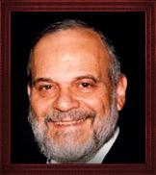

**Rabbi Berel Wein**

Judaism constantly stresses the importance and worth of the individual. Even though there are billions of people living on our planet, the worth of the individual should not be diminished by this fact.

In the Torah reading of this week the L-rd informs Moshe that it was the action of one individual – Pinchas – that saved hundreds of thousands, if not millions of Jews from destruction**.** The bold and audacious act of one individual had the power and ability to turn away, so to speak, the wrath of G-d from the Jewish people at a moment of crisis.

Positive acts of individuals that are bold and different do not usually result in public approval. In fact, many times that individual is roundly criticized by the general public and his behavior is seen to be incorrect, if not even immoral.

Yet, after time passes and the situation can be studied and analyzed in the light of later events and circumstances, it may become apparent that the criticized action of the individual was not only correct but was and is of immense value to society.

As an example, from recent history, Menachem Begin was pilloried and criticized for having prevented Saddam Hussein from acquiring nuclear weapons. All the do-gooders of the world and the United Nations clucked in disapproval and threatened action against Israel for this aggressive act.

A decade later the world begrudgingly acknowledged that this act of seeming aggression was really one of human salvation and enormous merit. The greatness of individuals lies in the fact that some of them are willing to swim upstream and do what is right even if it is unpopular and dangerous.

One of the rites of passage into male adult Jewish life is the institution of Bar Mitzvah. In a very clear way this ancient Jewish celebration reinforces the idea of the worth of each individual Jew. When we add another individual to the Jewish nation, it is not just a matter of population and numbers. It is rather the addition of a special personality with talents that are unique to him, to a community that can and will benefit from those abilities.

In our synagogue this week a wonderful young man, Eliya Goldvicht will be called to the Torah on the day of his Bar Mitzvah. Having grown up in our synagogue for the past four years he is known and beloved to all of us because of his wonderful talents, great smile and exemplary conduct. He is an individual who will undoubtedly make a mark on the Jewish community in future years.

Simply by knowing and appreciating him, as the synagogue membership has done over these past few years, the synagogue has reaffirmed this fundamental idea of the importance, uniqueness and greatness of the individual. All Jewish history, in fact all human history, is really the story of individuals and of their great accomplishments and even some of their disappointing failures. Eliya will be a great person that we will all be proud of and be able to say to later generations that we knew him when he became Bar Mitzvah.

*Reprinted from this week’s website of Rabbiwein.com*

**Poker at 5 A.M.**

**By Rabbi Eli J. Mansour**

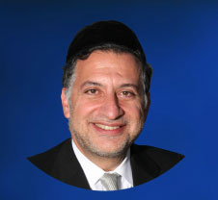

We read in Parashat Pinhas of the great reward G-d promised to Pinhas, Aharon’s grandson, for his act of zealotry during the tragic incident of Ba’al Pe’or, which the Torah relates toward the end of last week’s Parasha.  Zimri, the prince of the tribe of Shimon, committed an offense with a gentile woman in full view of Beneh Yisrael. Upon seeing the outrage, Pinhas approached the two violators and slew them, in response to which G-d brought an end to the plague that had killed 24,000 members of the nation who had sinned with the women of Moab.

A number of Rabbis wondered from where Pinhas drew the courage and conviction to commit such an act, bringing upon himself considerable criticism and condemnation. The Midrash relates how many among the nation sharply denounced Pinhas’ zealotry, and claimed that he acted with wanton violence, and not out of a sincere desire to avenge G-d’s honor.  Pinhas undoubtedly anticipated such a response, yet he was prepared to sacrifice his reputation in order to protest the disgrace perpetrated by Zimri. From where did he draw such inner strength and courage?

One Rabbi answered that Pinhas drew inspiration from – ironically enough – Zimri himself.  Zimri displayed such loyalty to his passions, to the point where he was prepared to sacrifice his reputation and noble stature in order to commit this sin.  He certainly knew that he would thereby forfeit his position as tribal leader and compromise his standing in the nation. But he accepted these consequences and was willing to make these sacrifices for the sake of satisfying his Yeser Ha’ra (evil inclination).

This “devotion” to the Yeser Ha’ra inspired Pinhas. If Zimri could make such great sacrifices for the sake of sin, then certainly he, Pinhas, could make at least the same sacrifices for the sake of G-d. Pinhas saw Zimri sacrifice his reputation and standing, and realized that he should do the same.  Zimri’s loyalty to his passions thus inspired Pinhas to show this same degree of loyalty to his G-d and to his nation.

Once, as I was riding a train, I overheard a passenger telling another about his daily schedule.  He would wake up each and every morning, without fail, at 5 A.M. to participate in an on-line poker game. At 8 A.M. – three hours later!! – he would stop, so that he could shower, eat breakfast and get to work by 9 A.M.

Upon hearing of this man’s daily poker game, I could not help but think about the forty days during the year – the forty days before Yom Kippur – that we Jews must arise for Selihot services at 5 A.M. This is a great challenge, to wake up so early and alter our schedules during this period in order to be at the synagogue promptly at 5 A.M. for five weeks.  But I realized that if this man could show such loyalty and devotion to a meaningless card game, to waste three hours of his day, then certainly we could exhibit at least this much loyalty to Misvot.

We may likewise draw inspiration from the rampant culture of immodest fashion in contemporary society. Women today go to great lengths and make enormous sacrifices in order to dress in accordance with contemporary fashion. They compromise their personal dignity and their innate modest nature in order to fit in, to meet the dreadfully low standards of society.

All the more so, then, must we make the sacrifices necessary to uphold the standards of the Torah, and dress and act in accordance with Halacha even when this is inconvenient and requires going against societal trends. If sinners can show unyielding commitment to their Yeser Ha’ra, then we must show at least this level of commitment to G-d and His Torah.

*Reprinted from this week’s website of the Edmund J. Safra Synagogue in Brooklyn, NY.*

**What It’s Like to Lead**

**The Small Jewish Burial Society in San Diego**

**By Menachem Posner**

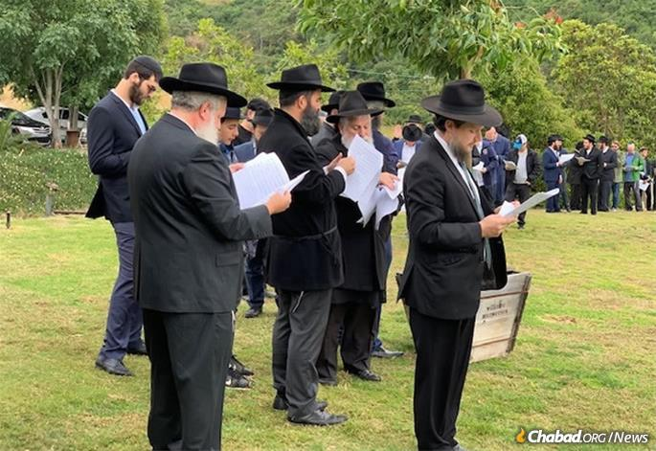

**Rabbis and community members gather for the consecration of a new Jewish cemetery area in San Diego.**

A central organ of Jewish communal life is the *[chevra kadisha](https://www.chabad.org/library/article_cdo/aid/4107711/jewish/The-Chevra-Kadisha.htm" \o "The Chevra Kadisha)*, the “sacred society” that performs the final rites for the Jewish deceased. In larger communities, the *chevra kadisha* may contain dozens of volunteers or paid staff. In smaller communities, however, it is usually a small, dedicated group of unsung heroes who prepare the departed for a Jewish burial.

In this conversation, Rabbi Rafi Andrusier, 32, who co-directs [Chabad of East County](https://www.jewishec.com/) in San Diego with his wife, Chaya, discusses the ins and outs of serving as men’s coordinator for the city’s *chevra kadisha*.

Q: First, some technical details. How is the *chevra kadisha* organized, and who are your key partners?



**Rabbi Rafi Andrusier leads the Chevra Kadisha, the Jewish Burial Society, in San Diego**

A: There are two separate teams, one male and one female, so that each deceased person is treated with the dignity and modesty we would have accorded them during their lifetime.

We work closely with a local Jewish mortuary. When a family requests a traditional burial, we are called, and I coordinate with a fellow member of the men’s *chevra kadisha* to perform the[*taharah*](https://www.chabad.org/library/article_cdo/aid/367843/jewish/The-Taharah.htm), the washing and dressing of the body. The women generally go with a team of three because they find it more difficult to maneuver the deceased.

We occasionally get calls to perform the *taharah* in other funeral homes, but it is much more difficult because typically they do not have all the items we use—white shrouds, washing cups, soil from Israel to place in the hands, buckets and earthenware shards to cover the eyes—and don’t understand our needs.

Q: How did you get involved in the *chevra kadisha*?

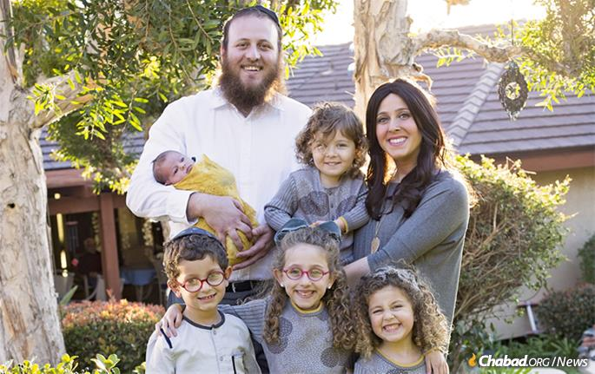

**Rabbi Rafi and Chaya Andrusier, co-directors of Chabad of East County in San Diego, with their children**

A: My wife and I founded our Chabad House in 2012. I was originally recruited by Rabbi Aharon Shapiro, who lives in San Diego and travels all over the world as a[*mashgiach*](https://www.chabad.org/library/article_cdo/aid/3851553/jewish/What-Is-a-Mashgiach.htm)(“kosher supervisor”). Since he is often on the road, he gradually shifted the responsibility to me. Both I and the person who most often joins me for *taharahs* live not far from the mortuary, which is in the older Jewish area of San Diego, so it works well for us.

Q: What’s it like to work with the departed?

A: It can be especially emotional when it’s someone you know. The rabbi of the Conservative congregation in my area passed away suddenly, and I was called in to do the *taharah*. We had a warm relationship and his death was hard for me, but I did it nonetheless.

At some point, I realized that as difficult as it is for us to care for someone we knew, that actually gives comfort to the family. People will often tell us that they are glad that we were able to care for their loved one and give them the *taharah*. They find it significant, and I am glad to be there for them in this way.

Q: Can you describe the experience and how you go about your duties?

A: It’s awesome, in the literal sense of the word, like Yom Kippur. Knowing that you are preparing someone to meet G‑d gives you a sense of reverence.

Before we begin and again when we finish, we verbally ask the deceased to forgive us for any indignity we may inadvertently cause them. We begin by removing bandages, cleaning the nails and generally removing whatever extras we can without causing bleeding. Even before we do the *taharah*, we wash and dry the body thoroughly, so it is clean.

Throughout the entire time, the face and private areas are covered, except for when we are working on them.

In a more established facility, the *taharah* is done by immersing the body in a *mikvah*. Since we do not have a *mikvah* here, we accomplish this by pouring nine *kav,*approximately 3 gallons, of water continuously over the body.

While this is going on, we speak as little as possible, and certainly don’t chat or joke. We are focused entirely on the dignity of the person we are preparing.

At the end, they are dressed in simple white shrouds in accordance with tradition, holding some soil from Eretz Yisrael, which I find very powerful.

Like all aspects of Jewish life, the values that we apply to how we treat the departed are not a given. We try our hardest to always remain cognizant of the fact that we are dealing with a real human being, a fellow Jew, a person like you and me.

*Reprinted from the Parashat Nasso 5779 email of Chabad.Org Magazine.*

**Let’s Make Calculations**

**By Rabbi Moshe Meir Weiss**

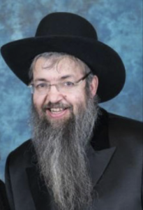

The posuk says, “Al kein yomru hamoshlim, ‘Bo’u cheshbon.’ ” The Gemora in Bava Basra [78b] interprets this verse homiletically as referring to hamoshlim b’yitzram, those who rule over their evil inclination.

The Medrash in Esther Rabbah teaches us, Reshaim br’shus libom – The wicked are controlled by their hearts.” On the other hand, “Tzadikim libom b’reshusom – The righteous control their hearts.”

One rules over their yeitzer when they know how to say no to temptation, when they stop short from revealing someone’s secret, from talking about a neighbor, when they are able to avert their gaze from immodesty, when they have the conviction to avoid distraction during their prayers.

The Gemora continues with its interpretation of the verse, “Bo’u cheshbon. Bo’u v’nachshov cheshbono shel olam – Come let us make a calculation about this world. Hefsed mitzvah k’neged schorah – The loss involved in doing a mitzvah against its reward.”

For example, the loss of business while going to mincha, or the loss of money when giving charity against the eternal rewards that it brings. And, “Schar aveirah k’neged hefseidah – The reward of transgression against its losses.” The temporary relief of getting angry at a spouse against the suffering of, “Kol hako’eis, kol minei gehenom sholtin bo – One who gets angry, all the treatments of hell will hold sway over him.”

What does the Gemora mean, “Cheshbono shel olam – The calculation of the world?” I’d like to explain it with a parable. What’s the difference between leasing a car for two years and owning a car? If you lease a car, you might not bother putting in premium gas (if the lease agreement gives you a choice). And, since you’re returning it in two years anyway, you won’t be so careful with your oil changes. And if you have a good protection plan, the scratches won’t bother you either.

But, if you own the car, you’ll make sure to put in the best gasoline, have very regular oil changes, and you’ll try to keep it in pristine condition because it’s yours for the long haul. Similarly, if you rent a bungalow, you’re not going to be too particular about its interior design. But, if you own a summer home, you’ll start thinking about hanging curtains and paintings.

It’s the same thing with life. If we view this world only for a stay of 90 years, then we might live only for the moment and seize fleeting pleasures. But, if we have a cheshbono shel olam and we think about eternity, then that drastically changes how we prioritize our choices and our uses of time.

We certainly wouldn’t want to risk embarrassing someone in public. That could cost us the loss of our eternity. We will surely indulge heavily in charity, for that is the money we take forever with us. And being that all of us will want to be a VIP in the permanent world of the Afterlife, we will surely want to invest heavily in the learning of Gemora of which we are taught, “Ashrei me shebah l’kan v’talmudo b’yado – Fortunate is he who comes to the next world with his Gemora in his hand.”

It’s important to note that the Gemora tells us that only those who rule over their yeitzer make these calculations. The average person davens daily and it doesn’t even bother them when they daydream through an entire Shemone Esrei, without even giving Hashem a moment’s thought.

Or when they swallow their berachos without thinking their meaning. Similarly, they can bentch – which is three Biblical mitzvahs and one mitzvah d’rabannan, without thinking once that they are saying thank you to Hashem. The reason for this phenomena is a technique of the Yeitzer Hara called, “Avar v’shana naaseh la k’heter;” when you do something once and then repeat it over and over again, it becomes as if its’s permissible.

If we said many Shemone Esreis without thought, after a while we don’t even feel a twinge of guilt. So too a person who often screams in the home, after a while he doesn’t even feel a twinge of remorse. The one who learns to control their Yeitzer Hara is always thinking and calculating so that they constantly adjust and improve their behavior.

May it be the will of Hashem that we should always monitor our behavior with an eye to daily betterment, and in that merit may Hashem bless us with long life, good health, and everything wonderful.

*Reprinted from the Parshas Balak 5779 email of the Jewish VUES.*